Name ___________________
ACTIVITY 7-5
WHICH MAN IS THE FATHER?

Directions: Complete the steps for the activity listed in your textbook. Record your results in the tables and answer the questions below.

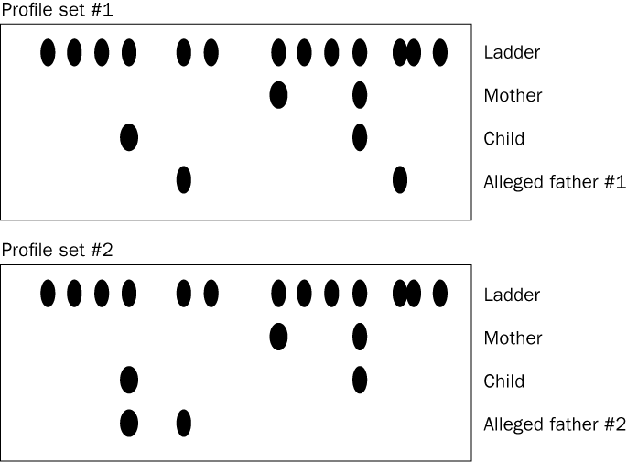

Questions:

1. Can either man be excluded as the father? Explain.

2. Which man may be the father of the child? Explain.

3. How many radioactive probes were used in this activity?

4. Is this DNA profile sufficient to establish paternity? Why or why not?

